

PRE-BID CHECK LIST

General Contractor/Customer Information

QLR Electric Name:
1295 Oregon Ct. Job name:
Concord, CA. 94521 Address:
(925) 595-5049
qlr@comcast.net Phone number:
Email:
- Style of receptacles  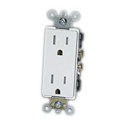  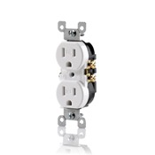
Decora/Designer Standard
 Other
- Style of switches  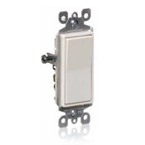  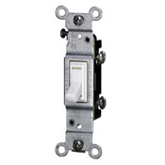
Decora/Designer Toggle
- Switch/dimmer/receptacle color  White  Ivory  Other ____________
- Dimmer style- Pick the style you like  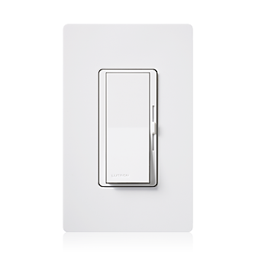  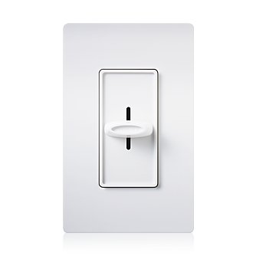
Diva Skylark

 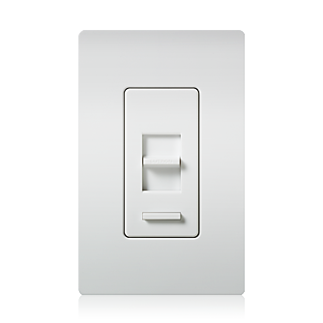  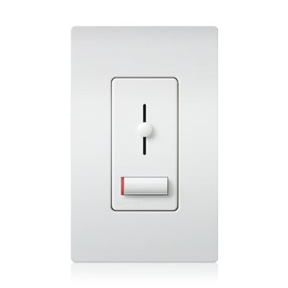  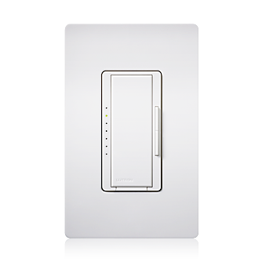  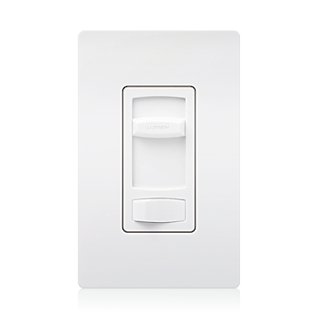
Lumea Lyneo Maestro Skylark Contour

 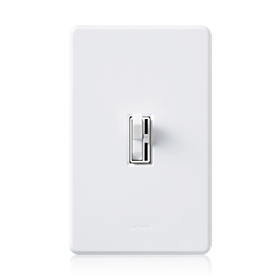  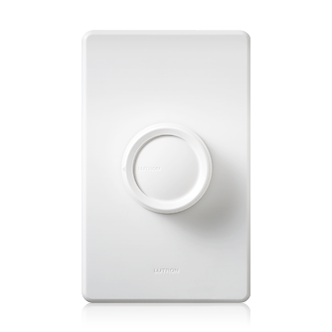
Ariadni/Toggler Rotary

- Puck lights  White  Ivory
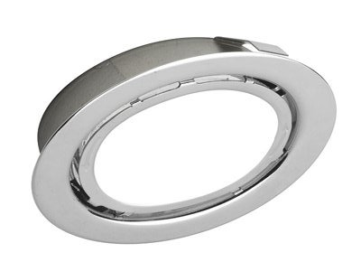  Black  LED ºK ________
 Other
- Under cabinet lights  Fluorescent  LED ºK
 Incandescent/ Xenon
- Pendant lights  Owner provided- owner to have on site or
provide cut sheet prior to rough-in
 Low voltage  Line voltage
- Recessed can lights:  LED- indicate size, which rooms, etc
Indicate ºK:
 2700K  3000K
 3500K  4100K
 Other ____________
______________________________________________________________________________

 Incandescent- indicate size, which rooms, etc

 Fluorescent- indicate size, wattage, rooms etc

 Low voltage MR-16 type- indicate rooms

 Trim- indicate size, color, style (baffle, eyeball/adjustable, etc)
- Ceiling fans  Yes  No
 Remote control  Wall control
 Pull chain control  Light kit
- Vaulted ceilings  Yes- indicate rooms

 No
- Bathroom exhaust fan:  Fan only- Brand
 Fan/light combo- Brand

 Owner provided
 Light switched separately

- Vacancy sensors:  Indicated on plans
 More than one vacancy sensor due to oddly
shaped room and indicated on plans
- New bathroom receptacle circuit per code  Yes  No
- Whirlpool tub circuit  Yes  120 volt  240 volt
 15 amp  20 amp
 No
 Heater circuit?  15 amp  20 amp
 120 volt  240 volt
- Wall sconces  Yes  No
 Owner provided
 Will have on site for rough-in purposes
 Indicated placement of outlet box on plans
- Outside wall sconces- Must be California Title 24 approved
 Owner provided
 Not owner provided- indicate style, make model, color, etc.
 Indicated placement to outlet box on plans
- Electrical rough-in window for range  Provide cut sheet with this information
See http://www.wolfappliance.com/resources/products/downloads/QRDF36.pdf for example  Provide legible make, model #
_______________________________________
_______________________________________

- Electrical rough-in window for oven  Provide cut sheet with this information
See http://www2.subzero-wolf.com/products/downloads/QRDO30.pdf for example
 Provide legible make, model # _______________________________________
_______________________________________
- Electrical rough-in window for refrigerator  Provide cut sheet with this information
See http://www.subzero.com/resources/products/downloads/QRBI-42SD.pdf for example
 Provide legible make, model #
_______________________________________
_______________________________________
- Electrical specs for range/cooktop  240volt/30-40-50amp (circle one)
 120volt for igniter only (gas range)
- Electrical specs for oven  240volt/30-40-50amp (circle one)
- Demolition:  Full tear out
 Walls out/ceiling stays
 All existing drywall stays
- Smoke alarms  Yes- indicated on plans  No
- Any strong walls?  Yes-side indicated on plans  No
- Any shear walls?  Yes- indicated on plans  No
- Exterior wall type  Stucco over ½” shear
 Siding- indicate thickness
- Any data-com outlets  Yes- indicated on plans  No
(Internet, telephone, TV)
- Indicated router/modem location  Yes  No

- Counter top receptacle height  Bath
(to center of)  Kitchen
- Backsplash  Material
 Height
 Full- countertop to upper cabinet
- New furnace  Yes  No
- New A/C condenser  Yes  30amp  40amp  50amp
 No
- Foundation  Crawl space  Slab
- Roof type  Comp  Tile
 Cementitious product  Metal
- Do all necessary kitchen circuits exist? Two 20amp small appliance  Yes  No
Separate disp/dishwasher  Yes  No
Microwave 20amp  Yes  No
Range amps  Yes  No
Oven amps  Yes  No
- Permitted job?  Yes  No
- Panel has enough room for added circuits  Yes  No
 Federal Pacific Stab-Lok- needs replacement
 Pictures of panel(s) included with plans
 Main service and panel(s) indicated on plans
- Tele-com services (TV, phone etc)  Overhead  Underground
- Electrical service  Overhead  Underground
- Electrical and gas meter locations- Over/under situation?  Yes  No

